Tumukunde Nadia 29/january/2024
Reg:22rp08856
HOMEWORK
Q1.describe oracle memory structures and background process.
Basic memory structures
Oracle database include several memory areas,each of which contains mulitiple subcomponent.The SGA is a group of shared memory structures known as SGA components,that contain data and control information for one oracle database instance.All server and background processes share the SGA
When the instance is started oracle database allocate memory area and start s background process
The memory area store information such as the following:
- Program code
- Information about each session even if it is not active
- Information needed during program execution
- Information such as lock data that is share and commutionicated and among process
- Cached data,such as data blocks and redo records that also exists on disk
Basic memory structures
- System Grobal Area:is a group of shared memory structures,known as a SGA components that contain data and control information for one oracle database instance.All server and background processes share the SGA .Examples of data stored in the SGA include cashed data blocks and shared sql area.
- Program grobal Area:is a nonshared memory region that contains data and control information exclussively for use by an oracle process.
- User Grobal Area:is a memory associated with user session.
- Software Code Area:are portion of memory used to store code that is being run or can be runn

Q2.Describe oracle logical and physical storage structure
Introduction to logical storage structure
Oracle database allocates logical space for all data in database.
The logical units of database space allocation are data blocks,extents,segments,and tablespaces.At a
on disk.The data in the data files is stored in operating system blocks.
Physical structures are those that can be seen and operated on from the operating system, such as the physical files that store data on disk. Logical structures are created and recognized by the Oracle database server and are not known to the operating system.
logical and physical storage
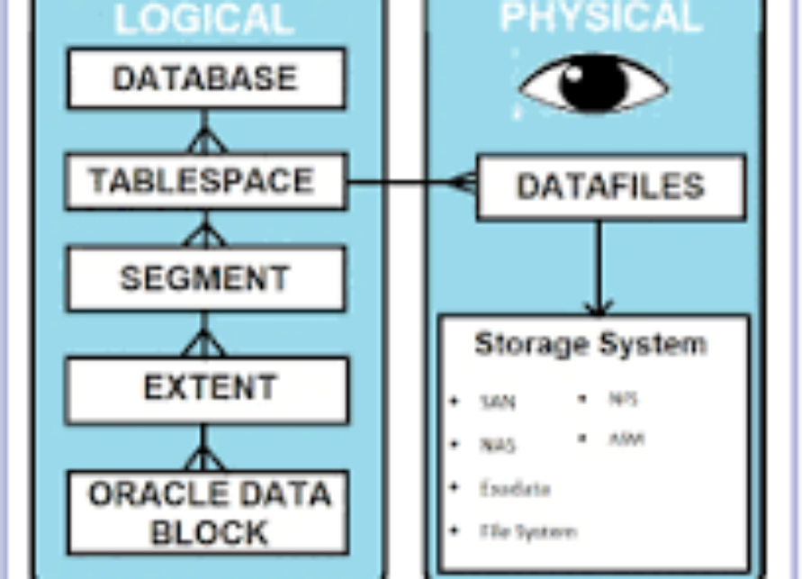
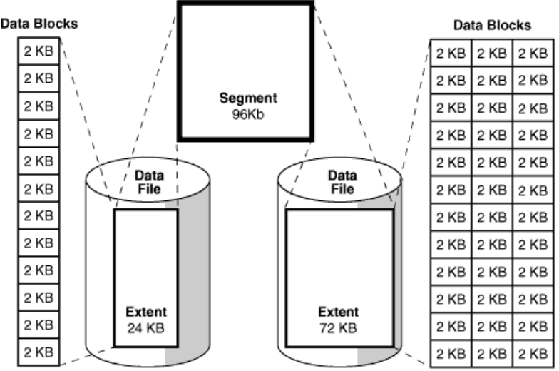

Descriptions
Description of "Figure 12-2 Segments, Extents, and Data Blocks Within a Tablespace"
From the lowest level of granularity to the highest, Oracle Database stores data

A data block is the smallest logical unit of data storage in Oracle Database.

One logical data block corresponds to a specific number of bytes of physical disk space, for example, 2 KB. Data blocks are the smallest units of storage that Oracle Database can use or allocate.

An extent is a set of logically contiguous data blocks allocated for storing a specific type of information

In the preceding graphic, the 24 KB extent has 12 data blocks, while the 72 KB extent has 36 data blocks.

A segment is a set of extents allocated for a specific database object, such as a table.

For example, the data for the employees table is stored in its own data segment, whereas each index for employees is stored in its own index segment. Every database object that consumes storage consists of a single segment.

A tablespace is a database storage unit that contains one or more segments.

Each segment belongs to one and only one tablespace. Thus, all extents for a segment are stored in the same tablespace. Within a tablespace, a segment can include extents from multiple data files, as shown in the preceding graphic. For example, one extent for a segment may be stored in users01.dbf, while another is stored in users02.dbf. A single extent can never span data files.
This section discusses the database files generated when you issue a CREATE DATABASE statement to create a CDB:

Data files and temp files

A data file is a physical file in persistent storage that was created by Oracle Database and contains data structures such as tables and indexes. A temp file is a data file that belongs to a temporary tablespace. The database writes data to these files in an Oracle proprietary format that cannot be read by other programs.

When you create a PDB within a PDB, the PDB has its own set of data files within the overall set of data files that makes up the CDB. For example, you could create a CDB named mycdb, and then create two PDBs within it: hrpdb and salespdb. In this case, mycdb would have its own set of data files and temp files, as would hrpdb and salespdb.

Control files

A control file is a root file that tracks the physical components of the CDB. PDBs do not have their own separate control files.

Online redo log files

The online redo log is a set of files containing records of changes made to data within the CDB. PDBs do not have their own separate online redo log files.

